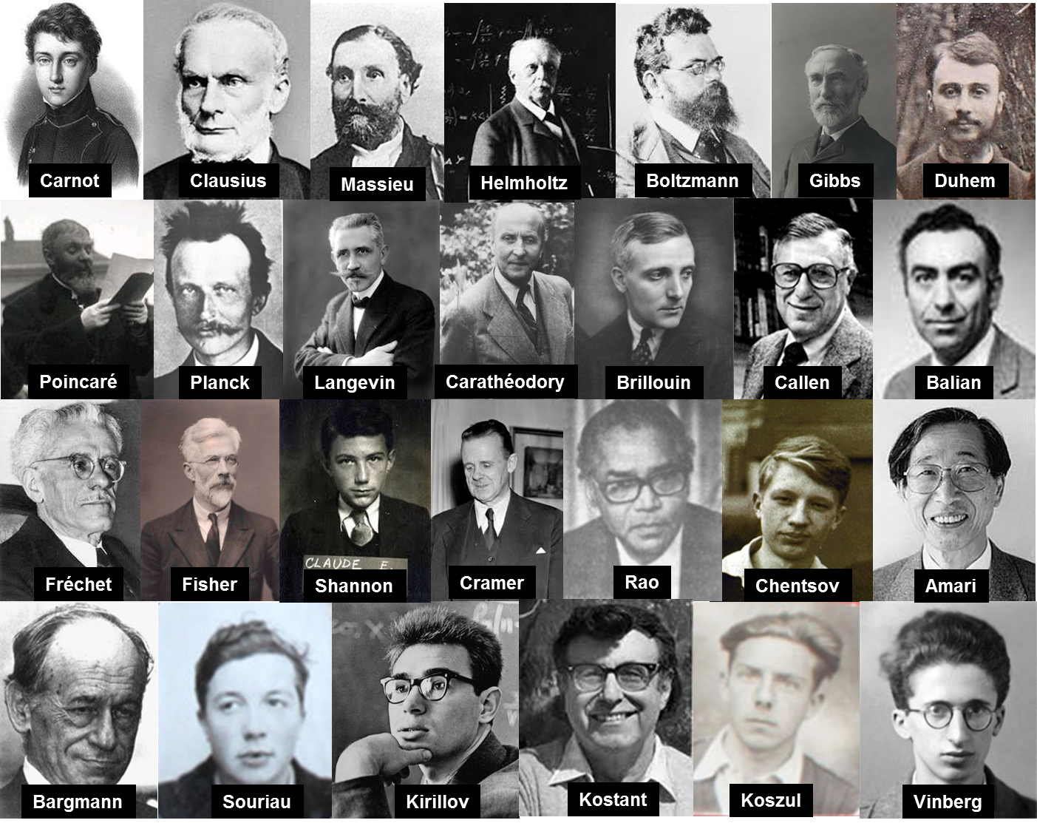

**Title**

**Joint Structures and Common Foundation of Statistical Physics, Information Geometry and Inference for Learning**

**Subject**The conference will deal with the following topics:

* ***Geometric Structures of Statistical Physics and Information***
  + Statistical Mechanics and Geometric Mechanics
  + Thermodynamics, Symplectic and Contact Geometries
  + Lie groups Thermodynamics
  + Relativistic and continuous media Thermodynamics
  + Symplectic Integrators
* ***Physical structures of inference and learning***
  + Stochastic gradient of Langevin's dynamics
  + Information geometry, Fisher metric and natural gradient
  + Monte-Carlo Hamiltonian methods
  + Varational inference and Hamiltonian controls
  + Boltzmann machine

**Dates**

26th July to 31st July 2020

**Organizers**

***Frédéric Barbaresco***, THALES, KTD PCC, Palaiseau

***Eric Moulines***, Ecole Polytechnique, CMAP, Palaiseau

***Frank Nielsen***, Ecole Polytechnique, LIX, Palaiseau & SONY CSL, Tokyo

***Silvère Bonnabel***, Mines ParisTech, CAOR, Paris

***Bernhard Maschke***, Université Claude Bernard, LAGEPP, Lyon

***François Gay-Balmaz***, Ecole Normale Supérieure Ulm, CNRS & LMD, Paris

***Gery de Saxcé***, Université de Lille, LAM3, Lille

***Patrick Iglesias-Zemmour***, Université de Marseille, I2M, Marseille

**Scientific Rational**

In the middle of the last century, Léon Brillouin in "The Science and The Theory of Information" or André Blanc-Lapierre in "Statistical Mechanics" forged the first links between the Theory of Information and Statistical Physics as precursors.

In the context of Artificial Intelligence, machine learning algorithms use more and more methodological tools coming from the Physics or the Statistical Mechanics. The laws and principles that underpin this Physics can shed new light on the conceptual basis of Artificial Intelligence. Thus, the principles of Maximum Entropy, Minimum of Free Energy, Gibbs-Duhem's Thermodynamic Potentials and the generalization of François Massieu's notions of characteristic functions enrich the variational formalism of machine learning. Conversely, the pitfalls encountered by Artificial Intelligence to extend its application domains, question the foundations of Statistical Physics, such as the construction of stochastic gradient in large dimension, the generalization of the notions of Gibbs densities in spaces of more elaborate representation like data on homogeneous differential or symplectic manifolds, Lie groups, graphs, tensors, ....

Sophisticated statistical models were introduced very early to deal with unsupervised learning tasks related to Ising-Potts models (the Ising-Potts model defines the interaction of spins arranged on a graph) of Statistical Physics. and more generally the Markov fields. The Ising models are associated with the theory of Mean Fields (study of systems with complex interactions through simplified models in which the action of the complete network on an actor is summarized by a single mean interaction in the sense of the mean field).

The porosity between the two disciplines has been established since the birth of Artificial Intelligence with the use of Boltzmann machines and the problem of robust methods for calculating partition function. More recently, gradient algorithms for neural network learning use large-scale robust extensions of the natural gradient of Fisher-based Information Geometry (to ensure reparameterization invariance), and stochastic gradient based on the Langevin equation (to ensure regularization), or their coupling called "Natural Langevin Dynamics".

Concomitantly, during the last fifty years, Statistical Physics has been the object of new geometrical formalizations (contact or symplectic geometry, ...) to try to give a new covariant formalization to the thermodynamics of dynamic systems. We can mention the extension of the symplectic models of Geometric Mechanics to Statistical Mechanics, or other developments such as Random Mechanics, Geometric Mechanics in its Stochastic version, Lie Groups Thermodynamic, and geometric modeling of phase transition phenomena.

Finally, we refer to Computational Statistical Physics, which uses efficient numerical methods for large-scale sampling and multimodal probability measurements (sampling of Boltzmann-Gibbs measurements and calculations of free energy, metastable dynamics and rare events, ...) and the study of geometric integrators (Hamiltonian dynamics, symplectic integrators, ...) with good properties of covariances and stability (use of symmetries, preservation of invariants, ...). Machine learning inference processes are just beginning to adapt these new integration schemes and their remarkable stability properties to increasingly abstract data representation spaces.

Artificial Intelligence currently uses only a very limited portion of the conceptual and methodological tools of Statistical Physics. The purpose of this conference is to encourage constructive dialogue around a common foundation, to allow the establishment of new principles and laws governing the two disciplines in a unified approach. But, it is also about exploring new « chemins de traverse ».